Civil war in Liberia

UNSC Resolution: | 972
Date of adoption: | 13-Jan-1995
Operative paragraph: | 3
Demand number: | 972,0311

Sarah-Myriam Martin-Brûlé

Wording of demand

work together to implement the Accra Agreement by upholding the cease-fire, resuming disarmament and demobilization of combatants and implementing the other relevant aspects of the agreement in accordance with the timetable, including the prompt installation of the New Council of State

List of addressees of the demand

National Patriotic Front of Liberia, Government of Liberia, Central Revolutionary Council of the National Patriotic Front of Liberia, Lola Defence Force, Liberian National Conference, Liberian Peace Council, United Liberation Movement of Liberia for Democracy - Krahn, United Liberation Movement of Liberia for Democracy - Mandingo

Short-term compliance

Description of the addressee(s)’ conduct

“In accordance with the timetable set out in the Accra agreement, the Liberian parties were to have nominated a new five-member Council of State by 11 January 1995. However, when they met in Accra under the auspices of ECOWAS on 9 January, they were unable to reach agreement on the composition and chairmanship of the Council. The main bottleneck was the inability of AFL and Coalition forces (ULIMO-J, LDF, LPC and CRC-NPFL) to reach agreement on their joint nominee. Nominees from the other parties included Mr. Charles Taylor, President of NPFL; Mr. Alhaji Kromah, Chairman of ULIMO-K; and Mr. Oscar Quiah, representative of LNC.”
UNOMIL, Liberia, Background
http://www.un.org/Depts/dpko/dpko/co_mission/unomilFT.htm#DECEMBER
“The Accra cease-fire lasted little more than a month, a period marked by wrangling over the composition of the interim Council of State. In February 1995 fighting resumed between the NPFL and the LPC In April 62 people, most of them women and children, died in a massacre at Yosi near Buchanan. (..) This was in an area controlled by the NPFL, but contested by the LPC.] Survivors said that the NPFL was responsible for the killings, and that the bodies of the dead had been used for cannibalism.”
WRITENET, Liberia: The Prospects for Peace - Update December 1994 - September 1996, 1 October 1996, available at: http://www.unhcr.org/refworld/docid/3ae6a6b814.html

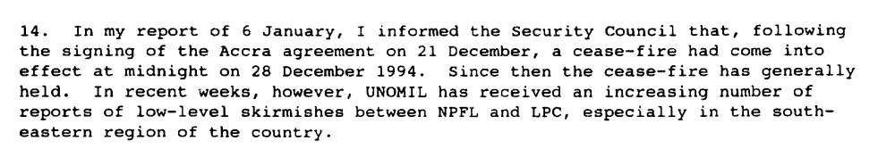

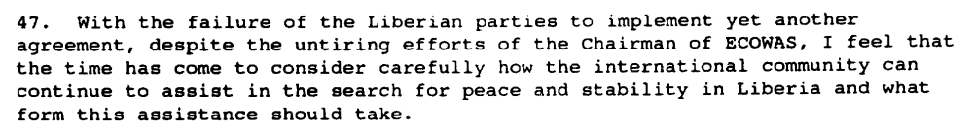
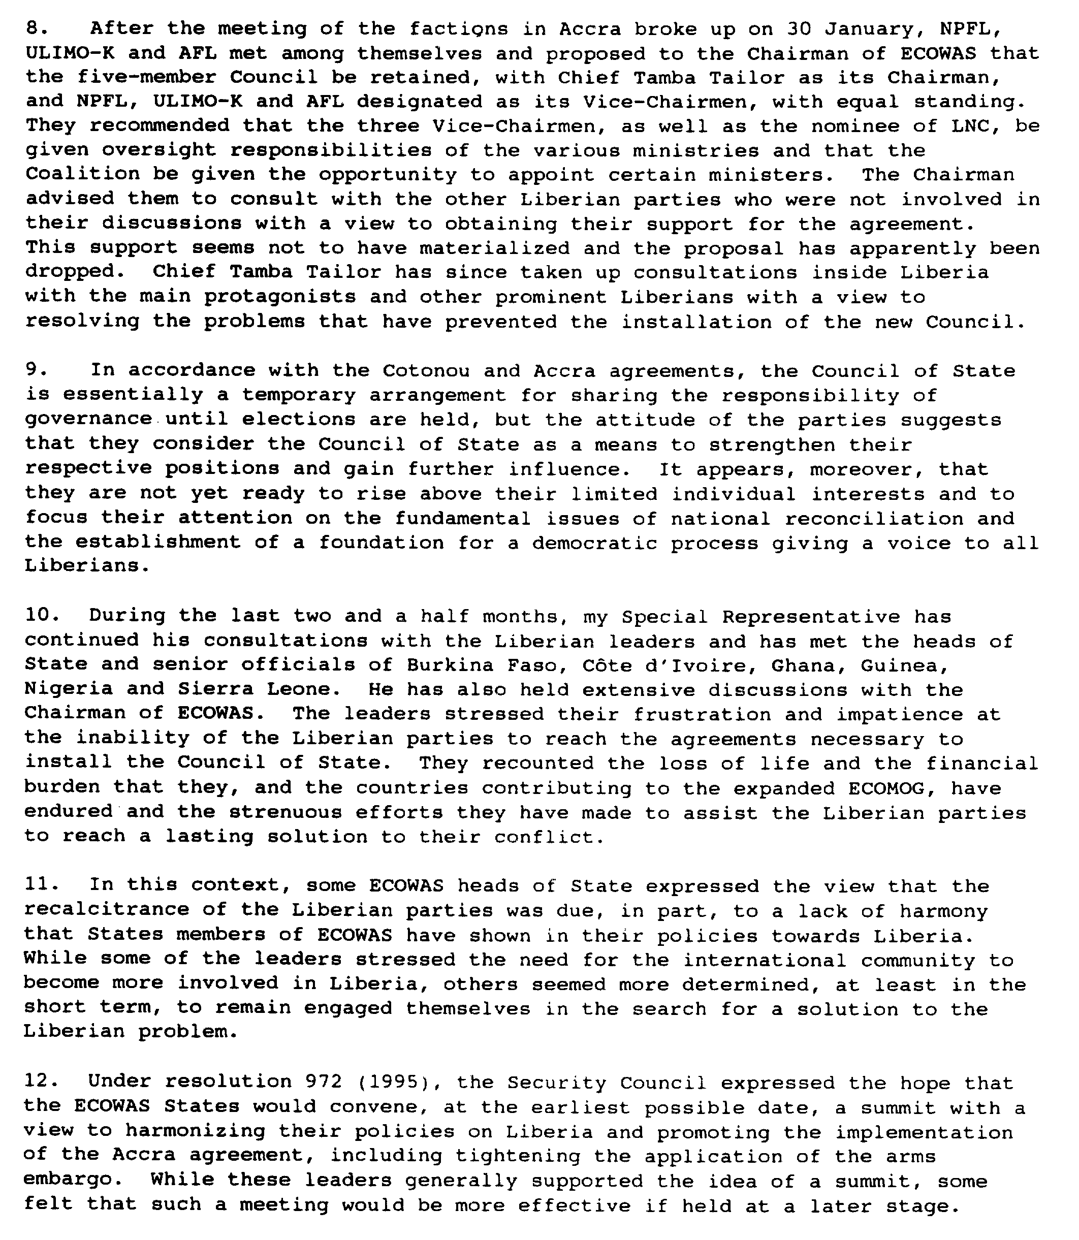
Ninth Progress Report of the Secretary-General on the United Nations Observer Mission in Liberia, S/1995/158, 24 February 1995

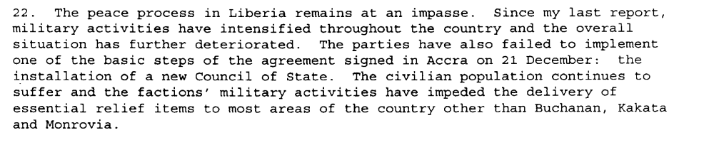
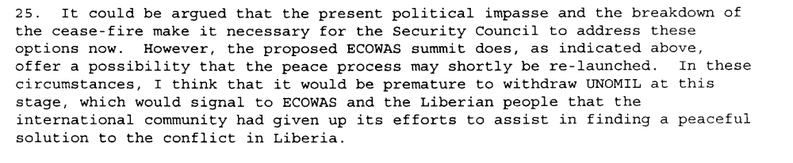
Tenth Progress Report of the Secretary-General on the United Nations Observer Mission in Liberia, S/1995/279, 10 April 1995

“The Accra agreement had called for a cease-fire by 28 December 1994 and the installation of a new Council of State by 11 January 1995. Neither event happened. The Liberian parties met in Accra under ECOWAS auspices in early January 1995 in a bid to agree on the composition and chairmanship of the Council of State. But the talks deadlocked. On 24 January, an ECOWAS minisummit was hosted again in Accra by the indefatigable ECOWAS chairman, Jerry Rawlings- the Pied Piper of Accra, who continued to play diplomatic tunes to which Liberia’s warlords often refused to dance.“ (Adebajo 2002: 165)

“The ECOWAS foreign ministers also met with the Liberian parties on 19 May to discuss the status of the Council of State. A six-member council was proposed (…). All parties except the LPC supported Tailor’s candidacy, and all except the NPFL backed the role of the Committee of Nine in choosing a successor. ULIMO-K argued for three vice chairmen; the NPFL and LPC favored two vice chairmen” (Adebajo 2002: 167)
Adebajo, Adekeye. 2002. Liberia’s Civil war: Nigeria, ECOMOG and Regional Security in West Africa. A project for the International Peace Academy. Lynne Rienner Publisher

Assessment

Short-term compliance
No or marginal compliance (1) | X Medium low compliance (2) | Medium high compliance (3) | Full or almost full compliance (4)

Considerations underlying the assessment

The demand addressees worked together yet they failed uphold the cease-fire, resume disarmament and demobilization of combatants and implement the other relevant aspects of the agreement in accordance with the timetable, including the prompt installation of the New Council of State.

Medium-term compliance

Description of the addressee(s)’ conduct

Despite efforts to establish a cohesive Council of State, the faction leaders on the Council remained deeply mistrustful of one another. The climate worsened on 31 October when, in an apparent assassination attempt on Councilman Charles Taylor, five persons, including a close personal aide to Mr. Taylor, were killed at the Executive Mansion. As a result of the deep divisions which resurfaced within the Council of State following this incident, the Council did not meet again until 16 January 1997. A joint investigation of the incident was undertaken by the Ministry of Justice, UNOMIL and ECOMOG.
UNOMIL, Liberia, Background
http://www.un.org/Depts/dpko/dpko/co_mission/unomilFT.htm#DECEMBER

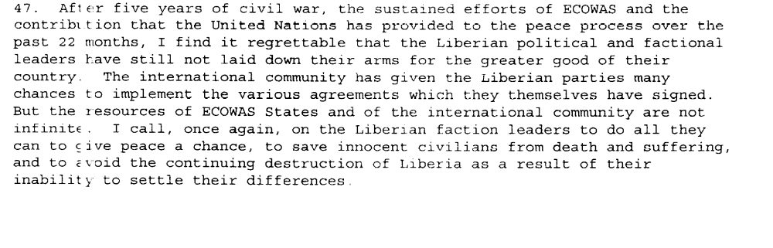
Eleventh Progress Report of the Secretary-General on the United Nations Mission in Liberia, S/1995/473, 10 June 1995

“On September 1 (1995) the Council of State was inaugurated in Monrovia’s grand Centennial Hall. (…)”
“The Presence of warlords in government did not, however, have the expected result of achieving peace in Liberia. Fighting continued between the LPC and NPFL in the southeast; between the two wings of ULIMO in the west around the Lofa Bridge; and between NPFL and ULIMO-K in Gbarnga, Suacoco and St.Paul River Bridge in Bong County.” (Adebajo 2002 :183).
Adebajo, Adekeye. 2002. Liberia’s Civil war: Nigeria, ECOMOG and Regional Security in West Africa. A project for the International Peace Academy. Lynne Rienner Publisher

Assessment

Medium-term compliance
No or marginal compliance (1) | Medium low compliance (2) | X Medium high compliance (3) | Full or almost full compliance (4)

Considerations underlying the assessment

Within the two years following the adoption of the agreement, the demand addressees worked together to implement the Accra Agreement and to install a New Council of State. With the subsequent Abuja agreement, they succeeded in upholding, although temporarily, the cease-fire, resuming disarmament and demobilization of combatants and implementing the other relevant aspects of the agreement. Yet, these steps were not in accordance with the timetable agreed upon in the Accra Agreement and fighting and hostilities resumed afterwards.

Depth of demand

Assessment

Level of depth of demand
Low depth of demand (1) | X Medium depth of demand (2) | High depth of demand (3)

Considerations underlying the assessment

“The logic of Abuja accord was to give to the armed factions joint control of the government of Liberia, encouraging them to pursue by political means the interest which they had previously contested in battle. (…) it also offered all the factions a chance to occupy government positions.
(…)
The various factions could now combine control of the resources of the hinterland with opportunities offered by access to the facilities of a sovereign state. (Ellis 1999: 107).”
Ellis, Stephen. 1999. The Mask of Anarchy. New York University Press.

Level of confidence about coding decisions

Level of confidence about coding decision
Extremely high | X High | Moderate

Comments to IPI (if any)

